GNU Octave, version 3.8.2
Copyright (C) 2014 John W. Eaton and others.
This is free software; see the source code for copying conditions.
There is ABSOLUTELY NO WARRANTY; not even for MERCHANTABILITY or
FITNESS FOR A PARTICULAR PURPOSE. For details, type 'warranty'.

Octave was configured for "x86_64-pc-linux-gnu".

Additional information about Octave is available at http://www.octave.org.

Please contribute if you find this software useful.
For more information, visit http://www.octave.org/get-involved.html

Read http://www.octave.org/bugs.html to learn how to submit bug reports.
For information about changes from previous versions, type 'news'.

a = 1.000000
l = 1.000000
T = 0.100000

ε =
1.0000e-10

n = 10
k = 10
hx = 0.100000
ht = 0.010000

Начальное возмущение =
0.25 * sin(pi * x)

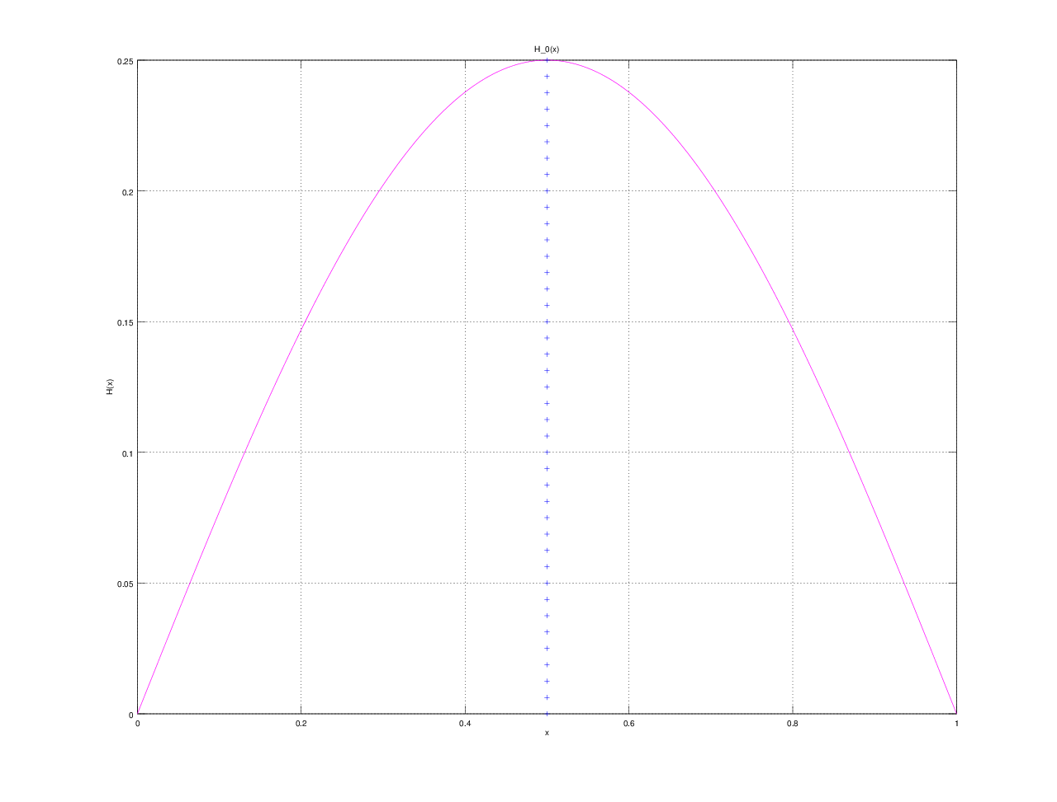

Всего демпферов: 1

Демпфер # 1

x_1 = 0.500000

Верхнее предельное значение w_1(t) =
NaN

Нижнее предельное значение w_1(t) =
NaN

Управляющая функция w_1(t):
-2842.63
2602.35
-2438.24
1990.08
-1357.44
600.42
324.86
-1336.71
2491.34
-3503.88
4755.08

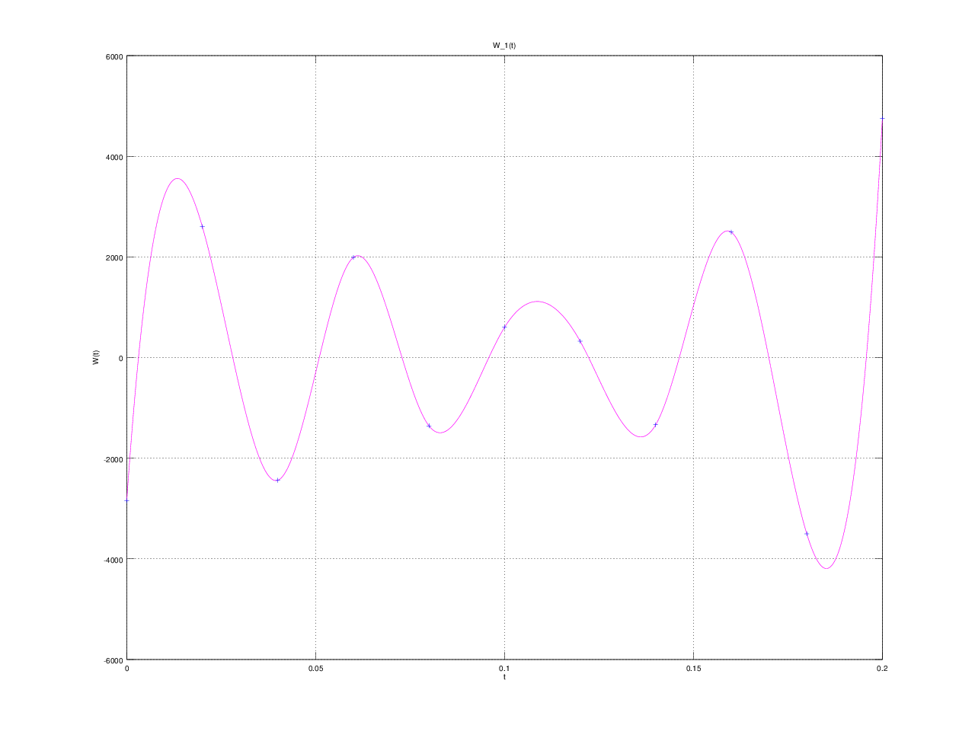

E(T) =
1.6838e-04

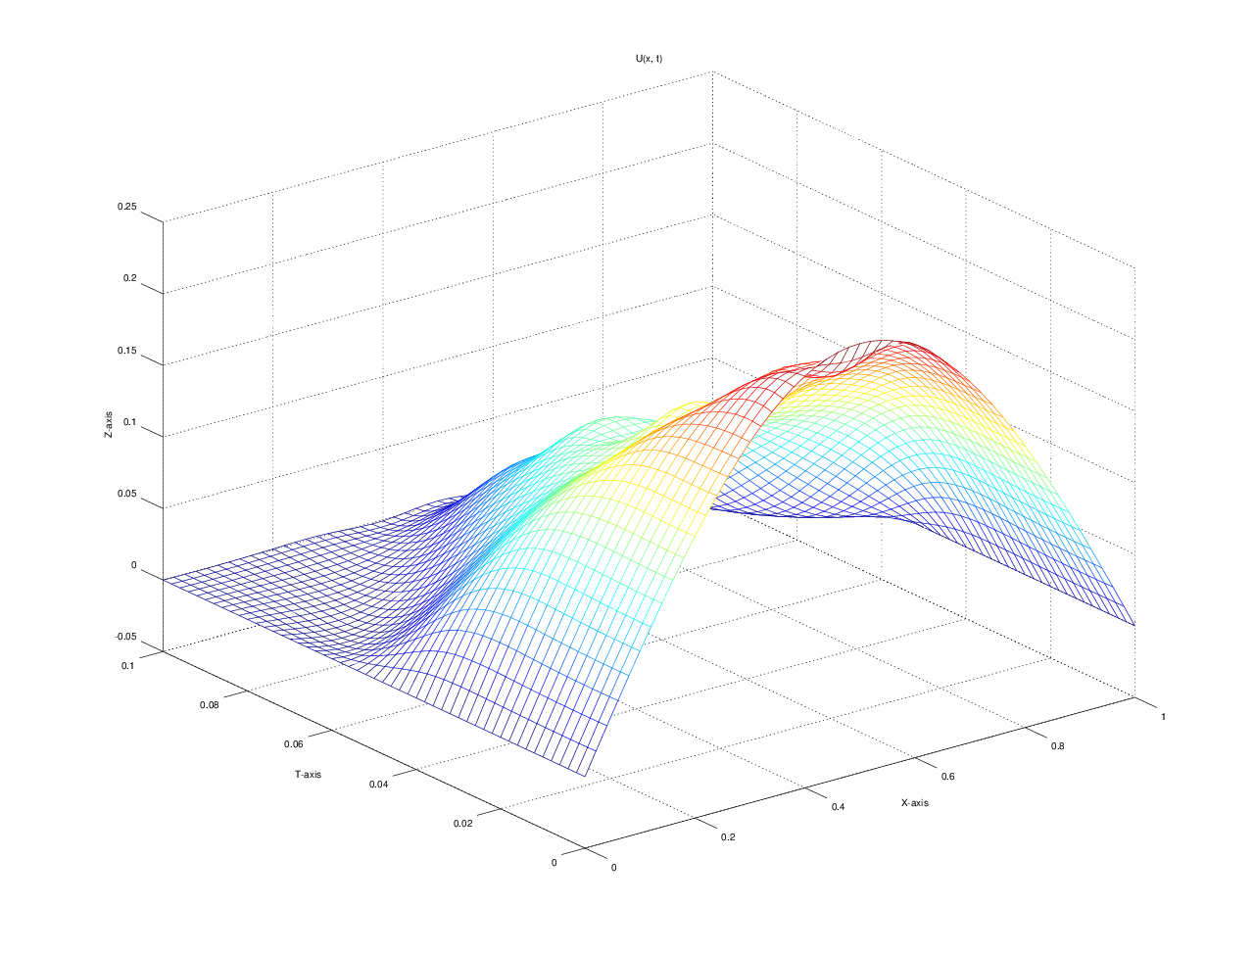

u(x, t)
T = 0.000000: 0.000000 0.077254 0.146946 0.202254 0.237764 0.250000 0.237764 0.202254 0.146946 0.077254 0.000000
T = 0.010000: 0.000000 0.077470 0.147190 0.199804 0.223576 0.214632 0.223576 0.199804 0.147190 0.077470 0.000000
T = 0.020000: 0.000000 0.078901 0.145368 0.184580 0.193329 0.201838 0.193329 0.184580 0.145368 0.078901 0.000000
T = 0.030000: 0.000000 0.078052 0.132468 0.155112 0.161312 0.148649 0.161312 0.155112 0.132468 0.078052 0.000000
T = 0.040000: 0.000000 0.063336 0.103421 0.123864 0.134323 0.153637 0.134323 0.123864 0.103421 0.063336 0.000000
T = 0.050000: 0.000000 0.032461 0.065596 0.095495 0.117794 0.115992 0.117794 0.095495 0.065596 0.032461 0.000000
T = 0.060000: 0.000000 0.004351 0.029543 0.067667 0.098585 0.115084 0.098585 0.067667 0.029543 0.004351 0.000000
T = 0.070000: 0.000000 -0.005315 0.005553 0.037098 0.070472 0.084081 0.070472 0.037098 0.005553 -0.005315 0.000000
T = 0.080000: 0.000000 -0.003066 -0.002149 0.011202 0.039201 0.057933 0.039201 0.011202 -0.002149 -0.003066 0.000000
T = 0.090000: 0.000000 -0.000759 -0.001213 0.001464 0.011366 0.022954 0.011366 0.001464 -0.001213 -0.000759 0.000000
T = 0.100000: 0.000000 -0.000189 0.000627 0.000889 -0.000877 0.002593 -0.000877 0.000889 0.000627 -0.000189 0.000000

